W2160 User Datasheet
(V1.0)

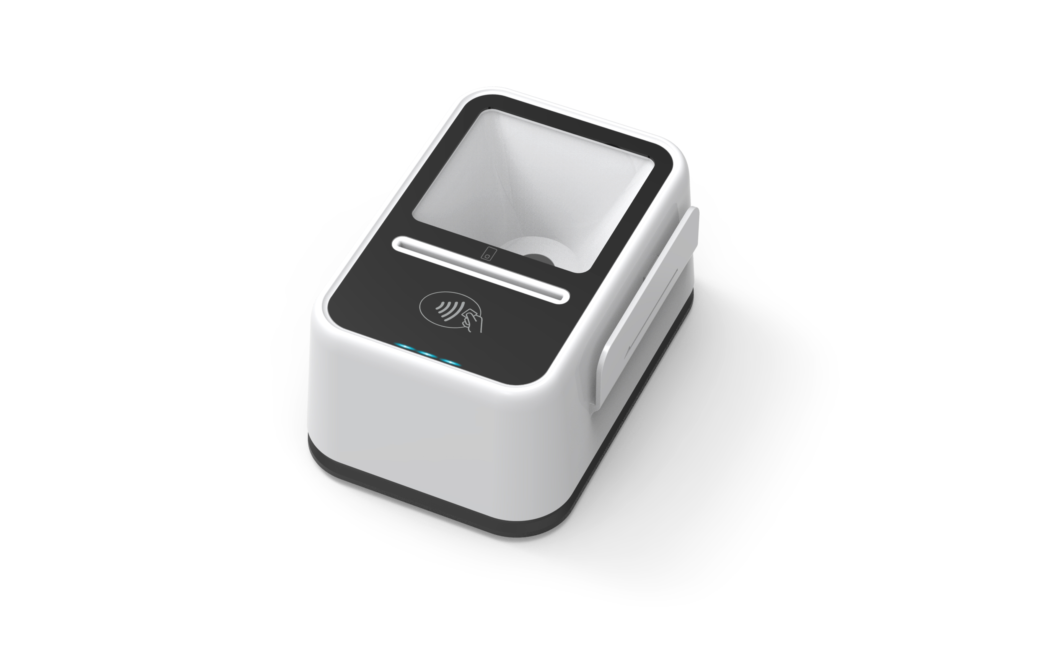

Beijing Watchdata Co. Ltd.

CONTENTS

1. GENERAL DESCRIPTION 3
2. READER FEATURES 3
3. COMMUNICATION PROTOCOL OF READER 5
4. THE FUNTIONS OF DLL 7
5. SELF-DEFINED COMMAND 10

GENERAL DESCRIPTION
W2160 is a highly integrated USB card reader, it integrates image scanning technology on the traditional smart card reader .It can support QR code or bar code scanning , and has a contact card slot and support contactless card operation. The reader also has a magnetic stripe card reading function, and can be equipped with a second-generation ID card information reading function to meet various needs of customers.

READER FEATURES
  - Support the contact card that satisfies standard ISO 7816－1/2/3/4
  - Support the contact I2C memory card, SLE4428, SLE4442,AT88SC1608
  - Support the contactless card that satisfies standard ISO14443 TYPEA and TYPEB
  - Support the Magnetic Strip card satisfies standard ISO 7810, ISO 7811,ISO 7812 and ISO 7813
  - full speed USB communication ,HID protocol
  - LED indicates the power or communication status
  - Embedded buzzer that can be controlled by the user
  - With the DLL, user can operate card conveniently

Module | Description
Scanner | 2D:QR code/ PDF417code;  1D: Code 128, Code 93, F-6, ITF-14, EAN-13, MSI- Plessey, Code 39 ,Code 11,etc.
Support Card type | Contact card : ID-1 size slot;Support T0, T1 protocol,I2C Memory Card ,SLE4428,SLE4442, AT88SC 1608;  Support 1.8V/3V/5V card  Contactless card： TYPEA /TYPEB/MAFIRE ONE  Read Range of Contactless Card is 0～4.5CM  Magnetic strip card: Support the second track and the third track reading  PSAM: Support 4 PSAM slots
Communication | Full Speed USB Interface with 12Mbps,HID communication Protocol
Indication | 3 LEDS & Buzzer; the red led indicates power status, the green led indicates contact card operation status, the blue led indicates contactless card operation status
Power Supply | USB power supply
MTBF | 5000 hours
Working Current | ≤500mA
Dimension | 127*79*65(mm)
Temperature | 0℃ ～ 50℃
Humidity | 20% ～ 90%
Shell Material | ABS
Operation system | Win XP/ Vista/ Win 7/Win 8/ Win 10/linux/

COMMUNICATION PROTOCOL OF READER

Remarks：All the command data is in hex .

PC –to-Reader data
Protocol  data | Abbreviations | lenth | Data Definitions
Headers | NAD  （slot ID） | 1 | 0x12：contact user card  0x15：contactless card  0x16：SAM slot1  0x17：SAM slot2  0x18：SAM slot3  0x19：SAM slot4  0x1A：Magnetic Strip card  0x00：self-defined command to reader
Headers | LEN1 | 1 | High byte of the APDU length
Headers | LEN0 | 1 | Low byte of the APDU length
APDU | CLA | 1
APDU | INS | 1
APDU | P1 | 1
APDU | P2 | 1
APDU | Lc | 1
APDU | DATA | 0-FF
(DLL function can add the headers automatically ,the user only need organize the data)

Reader-to-PC data
Protocol  data | Abbreviations | lenth | Data Definitions
Headers | NAD | 1 | Slot ID exchange its half-byte
Headers | LEN1 | 1 | 0x00
Headers | LEN0 | 1 | Low byte of the data and SW
Data | DATA | 0-FF | Card`s data
Data | SW1 | 1 | Status word high byte
Data | SW2 | 1 | Status word low byte

(DLL function can add the headers automatically ,the user only need organize the data)

Example1：Reset Contact CPU card

Reader to PC
12 00 05 00 12 00 00 00
↓ ↓ ↓ ↓ ↓ ↓ ↓ ↓
NAD LEN1 LEN0 CLA INS P1 P2 Lc

Reader to PC
21 00 13 3B6D0000574446224A864341301F131C12 90 00
↓ ↓ ↓ ↓ ↓ ↓
NAD LEN1 LEN0 (←-―――――D A T A－―-―――→) SW1 SW2

Example2：Select CPU card MF（3F00）
PC to Reader:
12 00 07 00 A4 00 00 02 3F 00
↓ ↓ ↓ ↓ ↓ ↓ ↓ ↓ ↓ ↓ ↓
NAD LEN1 LEN0 CLA INS P1 P2 Lc (D A T A)

Reader to PC
21 00 02 61 XX
↓ ↓ ↓ ↓ ↓
NAD LEN1 LEN0 SW1 SW2

THE FUNTIONS OF DLL

１） open the device function
HANDLE WINAPI CT_open(
char *name,
unsigned int param1,
unsigned char param2
);
Parameters：
name: "hid1","hid2","hidN" etc, 1<=N<=9
param1: Default 0
param2: Default 0
Return ：
INVALID_HANDLE_VALUE(-1) open failed；
INVALID_HANDLE_VALUE(fd) open success；
(fd : descriptor of the device)

2）Set NAD function
void WINAPI ICC_set_NAD(
HANDLE fd,
unsigned char nad
);
Parameters：
fd ：
nad ： slot ID (default 0x00)
Return：
NO
………
Example：
ICC_set_NAD(fDev,0x12); //set NAD is 0x12,contact card slot

３）Reset the card
unsigned WINAPI ICC_reset(
HANDLE fd,
unsigned char *lenr,
unsigned char *resp
);
Parameters：
fd ：
lenr ： the length of ATR (answer to reset )
resp ： ATR
Return status：
0x9000 Success
0x6200 No Ccard
0x6FF0 Time Out

４）send APDU function
Comm. ：CLA INS P1 P2 Lc DATA [Le]
Resp ：DATA

unsigned WINAPI ICC_tsi_api(
HANDLE fd,
unsigned char len,
unsigned char *comm,
unsigned char *lenr,
unsigned char *resp
);
Parameters：
fd ：
len ：The Length of comm
comm. ：APDU
lenr ：The length of the data from card
resp ：The data from card
Return status：
0x6FF0: Time Out
Others: SW1 SW2 from card

5）close the device function
int WINAPI CT_close(
HANDLE fd
);
Parameter：
fd ：the return of CT_open

Return:
-1：failed
0：success

Operating Process of the card
CT_open //open the device
ICC_set_NAD //Set slot ID (default 0x00)
ICC_reset //Reset card
…
ICC_tsi_api //send APDU
...
CT_close //Close the device

Application Example:
Get The Version Of Reader：
HANDLE fDev;
unsigned char lens; //
unsigned char lenr; //
unsigned char comm[300]; //
unsigned char resp[300]; //
unsigned int sw; //
char tmpbuf[300]; //
CString strDisplay; //

fDev =CT_open(hid1,0,0);
ICC_set_NAD(fDev,0x00); //set NAD 0x00
memcpy(comm,"\x00\x19\x00\x00\x00",5); // get Version
lens=5; //
sw=ICC_tsi_api(fDev,lens,comm,&lenr,resp); //
if(sw!=0x9000) //
{
MessageBox("Get Reader Firmware Version Error!");
}else
{
BinToCHex((unsigned char *)tmpbuf,resp,lenr); //
tmpbuf[lenr*2]=0;
strDisplay=CString(tmpbuf);
MessageBox("Firmware Version is "+strDisplay);
}

ICC_set_NAD(fDev,0x12); //set NAD 0x12 contact card slot
sw=ICC_reset(fDev,&lenr,resp) //reset card
memcpy(comm,"\x00\xa4\x00\x00\x02\x3f\x00",7); // select MF
lens=7; //
sw=ICC_tsi_api(fDev,lens,comm,&lenr,resp); //

SELF-DEFINED COMMAND
Self-defined command to device
NAD | CLA | INS | P1 | P2 | Lc | Data | Specification
00 | 00 | 19 | 00 | 00 | 00 |  | Get The Version Of Reader
00 | 00 | 19 | 01 | 01 | Le | data | Get The Serial Number Of Reader (Le<=20)  Data: The Serial Number Of Reader (in hex)
15 | B0 | 15 | 0E | 00 | 01 | 00 | Close RF field

Self-defined command to contact card
NAD | CLA | INS | P1 | P2 | Lc | Data | Specification
12 | 00 | 12 | 00 | 00 | 00 |  | Reset
12 | 00 | B0 | P1 | P2 | LEN |  | Read data from the memory card  SLE4442: P1 default 0；P2 address  SLE4428: P1(high byte of address)  P2(low byte of address）  LEN（data length）  LEN=0, read 256 bytes
12 | 00 | 20 | 00 | 00 | LEN | PIN | Check PIN  SLE4442: pin is 3bytes；  SLE4428: pin is 2bytes；
12 | 00 | D6 | P1 | P2 | LEN | Data | Write data to the memory card
12 | 00 | 24 | 00 | 00 | LEN |  | Change PIN

Self-defined command to contactless card
NAD | CLA | INS | P1 | P2 | Lc | Data | Specification
15 | 00 | 12 | 00 | 00 | 00 |  | Reset CPU card ( ISO14443 TYPEA/B)
15 | 80 | 11 | 09 | 00 | 00 |  | Reset Mifare one
15 | 80 | 11 | 02 | 00 | 08 | Key type(1 byte)+  block number(1 byte)  +key  Key type-keyA:0X60  Key type-keyB:0X61 | Authentication block
15 | 80 | 11 | 03 | 00 | 01 | block number | Read data
15 | 80 | 11 | 04 | 00 | 11 | block number+  data(16 bytes) | Write data
15 | 80 | 11 | 05 | 00 | 05 | block number+  amount (4 bytes) | Init wallet
15 | 80 | 11 | 06 | 00 | 05 | block number+  amount (4 bytes) | Increase
15 | 80 | 11 | 07 | 00 | 05 | block number+  amount (4 bytes) | Decrease

Self-defined Command to magnetic strip card
NAD | CLA | INS | P1 | P2 | Lc | Data | Specification
1A | 80 | 17 | 03 | P2 | 00 |  | In KBW mode ,the data of magnetic strip card  P2：  2. only the second strip data  3. only the third strip data  6. the second and the third strip data
1A | 80 | 17 | 03 | 00 | 01 | data | Read magnetic strip data in command mode  data：  2. only the second strip data  3. only the third strip data  6. the second and the third strip data
1A | 00 | 19 | 06 | P2 | 00 |  | Change mode  P2：  0，set to KBW mode  - set to command mode
1A | 00 | 19 | 20 | P2 | 00 |  | Waiting time (in command mode)  P2: time (S) (time < 180s)

SW1 SW2：
0x9000：Success
0x6D00：Not support command
0x6700：Length error
0x6FF0：Time out (communicate error)
0x6985：Write-protect (memory card )
0x6982： Not reach the secure state ( mifare one )
0x63CX：X is the number of attempt ( mifare one )
0x 6983/6984：Authentication failed ( mifare one )
0x 6FF0：Init error ( mifare one )
0x 6FF3：Write error (mifare one)
0x6902：Time out (magnetic strip card)

