W2160
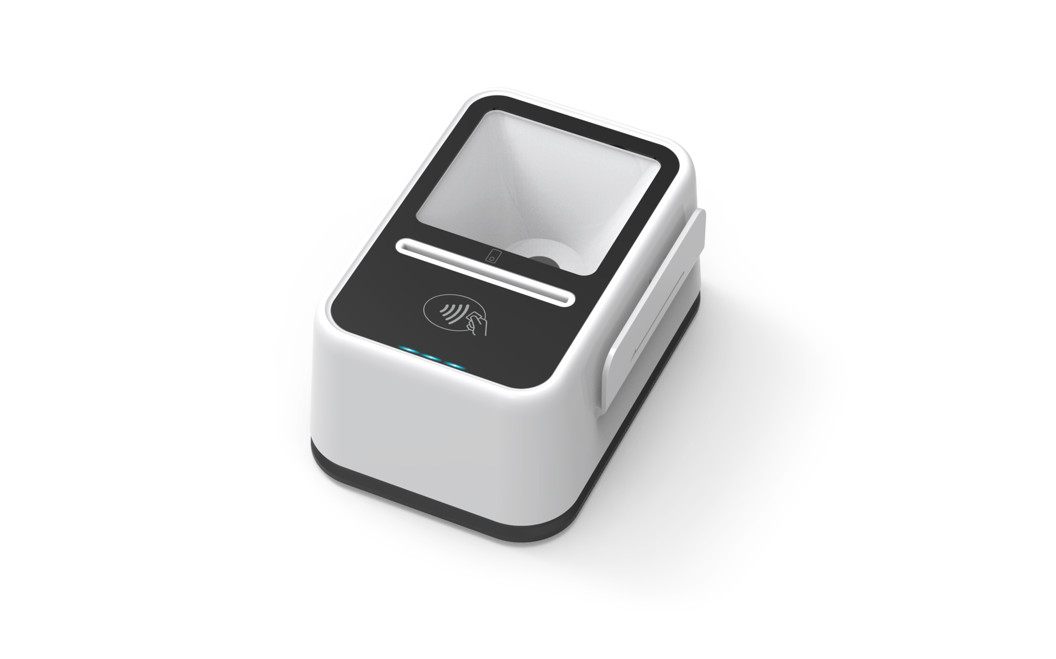
Product Specification

(V1.0)

Beijing Watchdata Co. Ltd.
2018/2

W2160 is a highly integrated USB card reader, it integrates image scanning technology on the traditional smart card reader .It can support QR code or bar code scanning , and has a contact card slot and support contactless card operation. The reader also has a magnetic stripe card reading function, and can be equipped with a second-generation ID card information reading function to meet various needs of customers.

READER FEATURES:
  - Support the contact card that satisfies standard ISO 7816－1/2/3/4
  - Support the contact I2C memory card, SLE4428, SLE4442,AT88SC1608
  - Support 1.8V/3V/5V Card
  - Support the contactless card that satisfies standard ISO14443 TYPEA and TYPEB
  - Support the Magnetic Strip card satisfies standard ISO 7810, ISO 7811,ISO 7812 and ISO 7813
  - Full speed USB communication ,HID protocol
  - LED indicates the power or communication status
  - Embedded buzzer that can be controlled by the user
  - With the DLL, user can operate card conveniently

Module | Description
Scanner | 2D:QR code/ PDF417code;  1D: Code 128, Code 93, F-6, ITF-14, EAN-13, MSI- Plessey, Code 39 ,Code 11,etc.
Support Card type | Contact card : ID-1 size slot;Support T0, T1 protocol,I2C Memory Card ,SLE4428,SLE4442, AT88SC 1608;  Support 1.8V/3V/5V card  Contactless card： TYPEA /TYPEB/MAFIRE ONE  Read Range of Contactless Card is 0～4.5CM  Magnetic strip card: Support the second track and the third track reading  PSAM: Support 4 PSAM slots
Communication | Full Speed USB Interface with 12Mbps,HID communication Protocol
Indication | 3 LEDS & Buzzer; the red led indicates power status, the green led indicates contact card operation status, the blue led indicates contactless card operation status
Power Supply | USB power supply
MTBF | 5000 hours
Working Current | ≤500mA
Dimension | 127*79*65(mm)
Temperature | 0℃ ～ 50℃
Humidity | 20% ～ 90%
Shell Material | ABS
Operation system | Win XP/ Vista/ Win 7/Win 8/ Win 10/linux/

